CHEADLE & GATLEY U3A – ANNUAL GENERAL MEETING
1.30 pm, Wednesday 10th June 2026
NOMINATION FORM
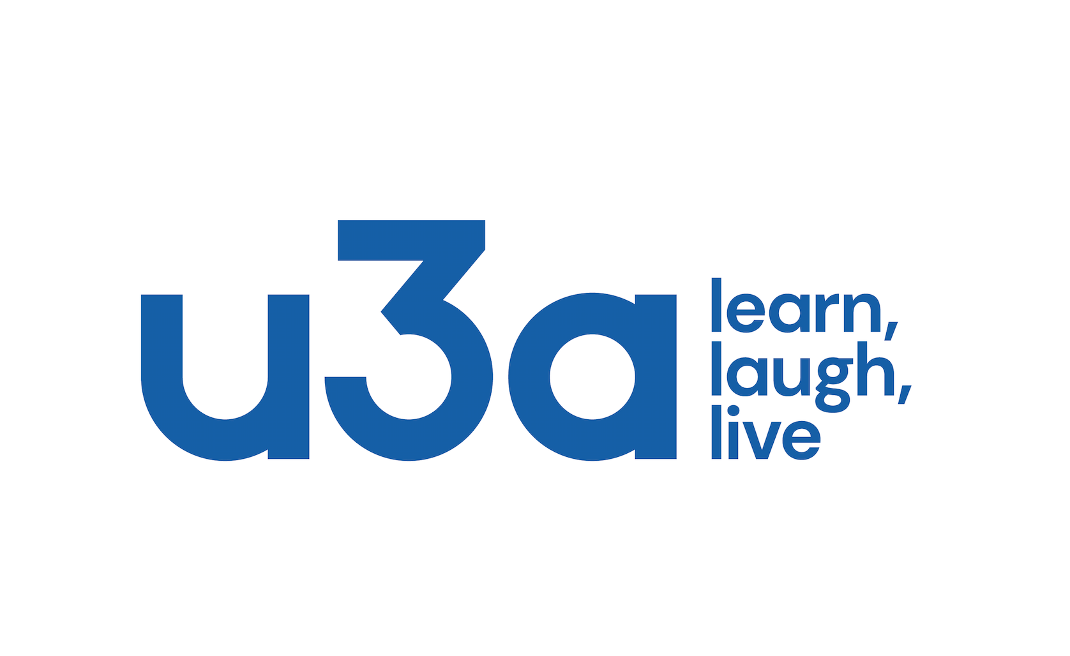
for Executive Committee 2026 -2027

PERSON BEING NOMINATED (Nominee)

Name:

Address: Postcode:

Telephone: Email:

PERSON MAKING the NOMINATION (Proposer) (Must be from Nominee’s U3A; please state office held, if any)

Name:

Address: Postcode:

Telephone: Email:

PERSON SECONDING the NOMINATION (Seconder) (Must be from Nominee’s U3A; please state office held, if any)

Name:

Address: Postcode:

Telephone: Email:

DECLARATIONS
1. I understand that the Nomination is for service on the Cheadle & Gatley Executive Committee from the date of the 2026 AGM (10th June 2026) for a period of one year.
2. I certify that the Proposer, the Nominee and the Seconder are members of Cheadle & Gatley U3A.

Signature of Proposer: Signature of Nominee:

Nominations must reach Margaret Seaby, Chair of the Cheadle & Gatley U3A, by 19th May 2026 and must be properly signed on this form. They may be sent by post to 45 South Park Rd, Gatley, SK8 4AL or scanned and emailed to Margaret Seaby at: mseaby@yahoo.com.

